ASSIGNMENT-06
NAME:P.VARSHITHA
BATCH:14
ENROLLMENT NO:2503A52398
TASK-1: Use an AI tool to generate a Python script that stores user data (name, email, password) in a file.
ANALYZE: Check if the AI stores sensitive data in plain text or without encryption.
INPUT:
import hashli
import json
import os
name = input("Enter your name: ")
email = input("Enter your email: ")
password = input("Enter your password: ")
user_data = {
"name": name,
"email": email,
"password": password
}
with open("users_insecure.txt", "w") as file:
json.dump(user_data, file, indent=4)
print("\nInsecure data stored in users_insecure.txt")
print("Privacy Risk: Password is stored in plain text.")
print("Anyone who can access the file can see the pass”)
hashed_password = hashlib.sha256(password.encode()).hexdigest()secure_data = {
"name": name,
"email": email,
"password_hash": hashed_password
}
with open("users_secure.txt", "w") as file:
json.dump(secure_data, file, indent=4)print("\nSecure data stored print("Password is stored as a SHA-256 hash.")
print("The original password is not stored in the file.")
print("\nHashed Password:")
print(hashed_password)
OUTPUT: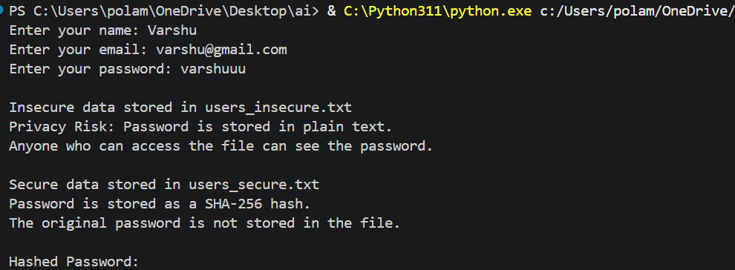
TASK DESCRIPTION-2: Fair Decision Logic Task: Prompt an AI tool to generate a scholarship eligibility checker based on academic score, family income, and location. Examine whether the logic unfairly favors or disadvantages any group.
INPUT:
# Scholarship Eligibility Checker

academic_score = float(input("Enter academic score (0-100): "))
family_income = float(input("Enter annual family income: "))
location = input("Enter location (urban/rural): ").lower()

if academic_score >= 75 and family_income <= 500000:
eligible = True
else:
eligible = False

print("\n--- Scholarship Result ---")

if eligible:
print("Student is ELIGIBLE for the scholarship.")
else:
print("Student is NOT ELIGIBLE for the scholarship."
print("\n--- Fairness Analysis ---")
print("Academic score and family income are relevant factors.")
print("Location is collected but is NOT used to make the decision.")
print("This avoids directly favoring or disadvantaging students based on location.")
OUTPUT: 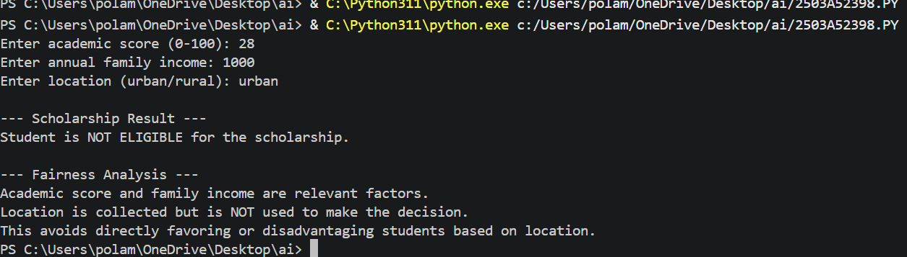

TASK-3(TRANSPARENCY IN AI-BASED ADMISSION SYSTEM): Use an AI tool to generate a Python program that predicts whether a student should be selected or rejected for admission based on factors such as entrance exam score, academic marks, and other relevant admission criteria.
ANALYZE: Check whether the AI system provides a clear and understandable reason for its admission decision.
INPUT:
entrance_score = float(input("Enter entrance exam score (0-100): "))
academic_marks = float(input("Enter academic marks (0-100): "))
interview_score = float(input("Enter interview score (0-100): "))
final_score = (
entrance_score * 0.50 +
academic_marks * 0.30 +
interview_score * 0.20
)
print("\n--- Admission Result ---")
print("Final Score:", round(final_score, 2))
if final_score >= 60:
decision = "SELECTED"
else:
decision = "REJECTED"
print("Decision:", decision
print("\n--- Decision Explanation ---")
if entrance_score >= 60:
print("Entrance exam score contributed positively.")
else:
print("Entrance exam score was below the preferred level.")
if academic_marks >= 60:
print("Academic marks contributed positively.")
else:
print("Academic marks were below the preferred level.")
if interview_score >= 60:
print("Interview score contributed positively.")
else:
print("Interview score was below the preferred level.")
print("\nImportant factors and their weights:")
print("Entrance Exam : 50%")
print("Academic Marks: 30%")
print("Interview : 20%")
OUTPUT:
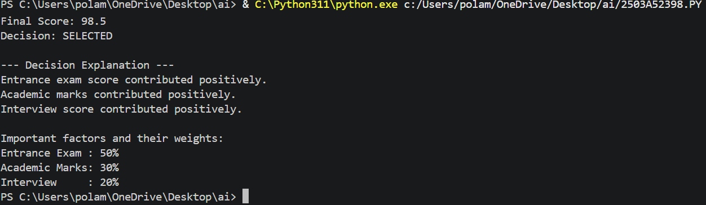
TASK DESCRIPTION-4: Ethical Scoring SystemTask: Generate an employee performance evaluation system using inputs such as project completion rate, teamwork score, and attendance. Analyze the scoring logic for any unethical weighting or hidden bias.
INPUT:
project_completion = float(
input("Enter project completion rate (0-100): ")
)
teamwork_score = float(
input("Enter teamwork score (0-100): ")
)
attendance = float(
input("Enter attendance percentage (0-100): ")
)
final_score = (
project_completion * 0.50 +
teamwork_score * 0.30 +
attendance * 0.20
)
print("\n--- Employee Performance Evaluation ---")
print("Project Completion:", project_completion)
print("Teamwork Score:", teamwork_score)
print("Attendance:", attendance)
print("Final Performance Score:", round(final_score, 2))
if final_score >= 80:
rating = "Excellent"
elif final_score >= 60:
rating = "Good"
elif final_score >= 40:
rating = "Average"
else:
rating = "Needs Improvement"
print("Performance Rating:", rating”)
print("\n--- Ethical Analysis ---")
print("Project completion has the highest weight because it directly")
print("represents completion of assigned work.")
print("Teamwork is also considered because collaboration is important.")
print("Attendance has a lower weight so that employees are not judged")
print("mainly on attendance alone.")
print("\nThe system should be reviewed regularly for hidden bias.")
print("Performance should be evaluated using job-related factors.")
OUTPUT: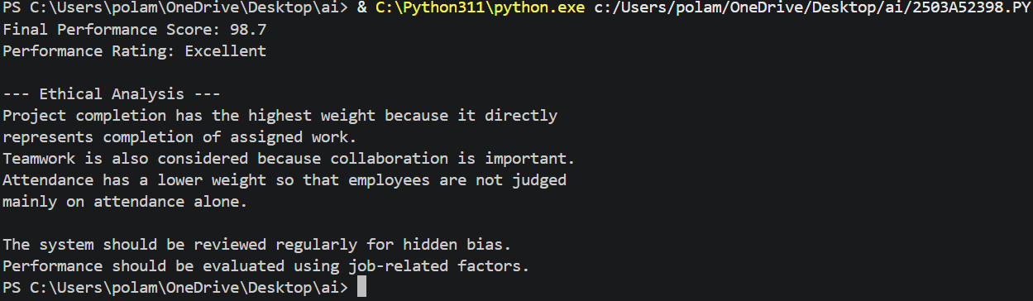
TASK DECRIPTION-5:Accessibility and Inclusiveness Task: Use an AI tool to generate a user feedback form application. Review whether the language and options provided are inclusive and accessible to diverse users.
INPUT:
print("=" * 50)
print(" USER FEEDBACK FORM")
print("=" * 50)
name = input("Name (optional): ")
print("\nHow would you rate your experience?")
print("1. Very Good")
print("2. Good")
print("3. Average")
print("4. Poor")
print("5. Very Poor")
print("6. Prefer not to say")
rating = input("Enter your choice: ")
print("\nWhich area would you like to give feedback about?")
print("1. Accessibility")
print("2. Website/Application")
print("3. Service")
print("4. Communication")
print("5. Other")
print("6. Prefer not to say")

area = input("Enter your choice: ")

feedback = input("\nPlease enter your feedback (optional): ")

print("\nDo you need any accessibility support?")
print("1. Yes")
print("2. No")
print("3. Prefer not to say")

accessibility = input("Enter your choice: ")

print("\n" + "=" * 50)
print(" FEEDBACK SUMMARY")
print("=" * 50)
print("Name:", name if name else "Not provided")
print("Rating:", rating)
print("Feedback Area:", area)
print("Accessibility Support:", accessibility)
print("Comments:", feedback if feedback else "Not provided")
print("\nThank you for your feedback!")
print("Your responses are treated respectfully and inclusively.")
OUTPUT:
